https://www.marketreportanalytics.com/reports/bangladesh-used-car-market-104541?utm_source=chatgpt.com#

Vehicle registration drops 15% to a decade low in 2024
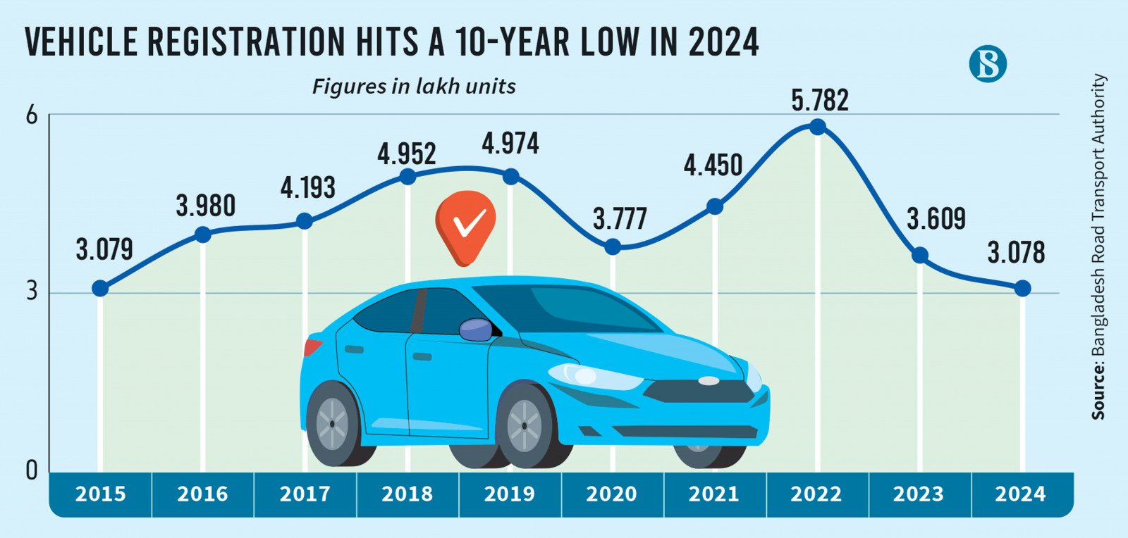

BRTA data shows that fewer than 3.08 lakh vehicles were registered in 2024, marking a 47% decline from 2022 .
https://www.tbsnews.net/bangladesh/vehicle-registration-drops-15-decade-low-2024-1033676

Car Price in Bangladesh – The Ultimate Market Analysis (Bangladesh Reconditioned Vehicles Importers and Dealers Association (BARVIDA) )
https://www.carbarn.com.bd/blog/car-price-in-bangladesh-2025-market-analysis
In 2024, the Bangladesh Reconditioned Vehicles Importers and Dealers Association (BARVIDA) reported that only 308,000 vehicles were registered, the lowest figure in a decade. In comparison, 2022 saw nearly 578,000 registrations.
High import costs and volatile exchange rates. But there’s hope: in early 2025, the Bangladesh Bank reduced the LC cash margin for car imports from 100% to 50%, easing liquidity pressures on importers.
This policy, along with new tax incentives for hybrid and electric vehicles, has already started reshaping the car price in Bangladesh across all categories.
Car Price in Bangladesh by Category
Category | Typical Price Range (BDT) | Market Trend (2025)
Brand-New Petrol/Diesel | Tk 30–70 lakh | Heavily taxed, slower demand
Reconditioned Used Cars | Tk 15–40 lakh | Most popular among middle-class buyers
Hybrid Cars | Tk 35–70 lakh | Strong demand, supported by VAT relief
Electric Vehicles (EVs) | Tk 45–100 lakh | Emerging segment; infrastructure limited
Locally Assembled Cars | Tk 28–45 lakh | Growing segment with lower duties
Among these, reconditioned Japanese imports dominate, making the used car Bangladesh market the backbone of national vehicle ownership.

Car Import Duty Bangladesh – The Real Price Driver
When it comes to high car prices, duties and taxes are the biggest culprits. The total car import duty Bangladesh can reach as high as 96% depending on vehicle type and size.
Here’s a simplified breakdown:
Vehicle Type | Approx. Total Duty & Tax Burden | Remarks
Petrol/Diesel | 89–127% | Highest duty category
Hybrid Cars (Imported) | 85–96% | Reduced slightly after VAT reform
Locally Assembled Hybrid/Electric | ~33% | New incentive introduced in 2025
Imported Electric Vehicles (EVs) | 85–90% | Still high due to battery cost
Microbuses (Reconditioned) | 40–55% | Lower duties to promote public transport

ELECTRIC MOBILITY AND SHIFT TO THE ELECTRIFICATION OF PARATRANSIT IN BANGLADESH
https://www.unescap.org/sites/default/d8files/event-documents/22%20_Electric%20_mobility%20_&%20_shift%20_to%20_electrification,%20_Bangladesh.pdf
